**Experiment 04 : Finding Negative Numbers from given array**

**Learning Objective**:

Student should be able to Identify negative numbers from a given sign array using Assembly language.

**Tools:** TASM/MASM

**Theory:**

In computing, signed number representations are required to encode negative numbers in binary number systems. The early days of digital computing were marked by a lot of competing ideas about both hardware technology and mathematics technology (numbering systems). One of the great debates was the format of negative numbers, with some of the era's most expert people having very strong and different opinions. One camp supported two's complement, the system that is dominant today. Another camp supported ones' complement, where any positive value is made into its negative equivalent by inverting all of the bits in a word. A third group supported "sign & magnitude" (sign-magnitude), where a value is changed from positive to negative simply by toggling the word's sign (high-order) bit. In mathematics, negative numbers in any base are represented by prefixing them with a − sign. However, in computer hardware, numbers are represented in bit vectors only, without extra symbols. The four best-known methods of extending the binary numeral system to represent signed numbers are: sign-and-magnitude, ones' complement, two's complement, and excess-K. Some of the alternative methods use implicit instead of explicit signs, such as negative binary, using the base −2. Corresponding methods can be devised for other bases, whether positive, negative, fractional, or other elaborations on such themes. There is no definitive criterion by which any of the representations is universally superior. The representation used in most current computing devices is two's complement. To check whether the number is negative, perform AND operation with 80H, if the number is negative, the result will be Non-zero (i.e. MSB is 1) and if number is positive then the result will be Zero (i.e. MSB is 0).

**Procedure/Algorithm:**

**Algorithm:**

1. Initialize index register with the offset of array of signed numbers

2. Initialize CX with array element count

3. Initialize negative number count to zero

4. Perform MSB test of array element

5. If set jump to step 6

6. Increment negative number count and continue

8. Point index register to the next element

9. Decrement the array element count from CX, if not zero jump to step 4, else continue

10. Display Negative number message and then display negative number count

12. EXIT

**Application:**

Use of array in the Assembly Language programming to write modular program.

**Design:**

**Result and Discussion:**

.MODEL SMALL

.STACK

.DATA

MSG1 DB 10,13,"NEGATIVE NUMBERS: $"

SPACE DB " $"

ARRAY DB 37H,15H,0AAH,058H,084H ;initialized array

N_ARRAY DB 5 DUP(0) ;Uninitialized array

.CODE

DISP MACRO XX

MOV AH,09

LEA DX,XX

INT 21H

ENDM

.STARTUP

LEA SI,ARRAY ;Source Array (+ve Array)

LEA DI,N_ARRAY ;Destination Array (-ve Array)

MOV CL,5 ;+ve Array Length

MOV BL,0 ;-ve Array Length

BACK:

MOV AL,[SI]

AND AL,80H ;To check Positive or negative; 80 -> 1000 0000; Checking First Bit

JZ POSITIVE ;Jump if Number is Positive

MOV AL,[SI]

MOV [DI],AL

INC DI

INC BL

POSITIVE:

INC SI

DEC CL

JNZ BACK

DISP MSG1

LEA DI,N_ARRAY

BACK1:

MOV BH,[DI]

AND BH,0F0H

MOV CL,4

SHR BH,CL

CMP BH,9

JG AA

ADD BH,30H

JMP AA1

AA:

ADD BH,37H

AA1:

MOV DL,BH

MOV AH,02

INT 21H

MOV BH,[DI]

AND BH,0FH

CMP BH,09

JG AA2

ADD BH,30H

JMP AA3

AA2:

ADD BH,37H

AA3:

MOV DL,BH

MOV AH,02

INT 21H

;MOV AH,13

;INT 21H

INC DI

DEC BL

DISP SPACE

JNZ BACK1

.EXIT

END

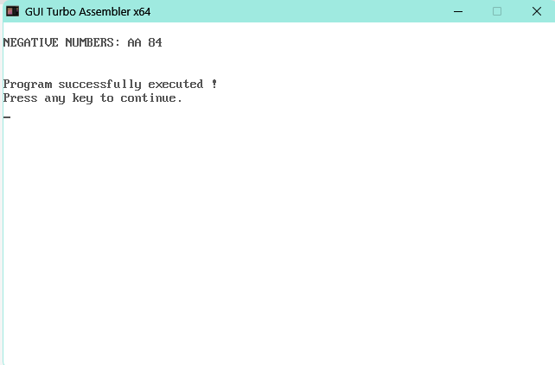

**Learning Outcomes:**

The student should have the ability to

LO1: Describe the string addressing mode.

LO2: Use of string instructions in the program to perform different string operations.

LO3: Write a program using array to find negative numbers from given signed array.

**Course Outcomes**:

Upon completion of the course students will be able to make use of instructions of 8086 to build assembly and Mixed language programs.

**Conclusion:**

**Viva Questions:**

1. How negative Numbers are represented in Computer System?
2. Explain how array is defined in ALP.
3. Explain the procedure to find negative numbers from given array.

**For Faculty Use**

|  |  |  |  |  |
| --- | --- | --- | --- | --- |
| **Correction Parameters** | **Formative Assessment [40%]** | **Timely completion of Practical [ 40%]** | **Attendance / Learning Attitude [20%]** |  |
| **Marks Obtained** |  |  |  |